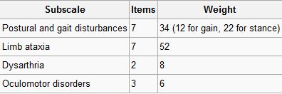

Postural and stance disturbances (subscore: /34)

Limb movement disturbances (subscore: /52)

Speech disorders (subscore: /8)

Oculomotor deficits (subscore: /6)